**STOCK MARKET CHARTING**

**Training Project**

**For**

**MIDDLEWARE TRAINING**

**(Milestone-1)**

**Submitted by**

**Chayan Gandhi**

**768754**

**(Programmer Analyst Trainee)**

**Tabel of Content Page no**

1. Stock Market Charting 1
2. Admin Login 1
3. Data Import 2
4. Manage Company 3
5. Manage Exchange 4
6. IPO Planned 5
7. User Registration & Login 6
8. User Company List 7
9. User Stock Charting 7-8
10. Database schema 9

**Stock Market Charting**  :- Charts are the primary tools for technical analysis. Charts conveniently visualize the price action by plotting the historical market data of the underlying financial instrument on a graph. This visual representation allows for easier identification of common and rare price patterns. Technical analysis tries to answer questions pertaining to the price action. What is the[support](https://www.investorsunderground.com/stock-charts/how-to-read-a-stock-chart/) and[resistance](https://www.investorsunderground.com/stock-chart-patterns/support-resistance/)? What is the [trend](https://www.investorsunderground.com/stock-chart-patterns/trend-lines/)? Where is the stock going? What is the sentiment on this stock? The answers to these questions are ultimately played out in time. Charts help traders to map out the price history and forward trajectory to make better-informed trades.

I have created the different phases of the stock market charting project and how the analysis is going to be done in the project. Here are the initial screens of the Project.

**Admin Login** :- The Admin can login into the portal using this screen and can get access to the admin functionality like adding the company and deactivating the company, maintain the ipo’s list, adding stocks and giving details about the stock price.

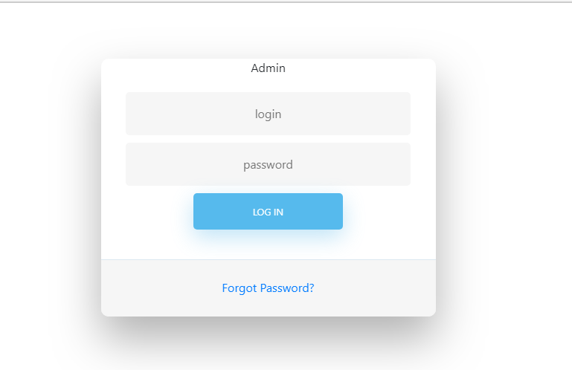

**Data Import :-** Form this page the admin can import the data of the Stock exchange like company code ,stock exchange, price, date and time. This allow the user for further making the charts of the stocks and company data according to the period. We have added functionality so that user can view format of the excel file

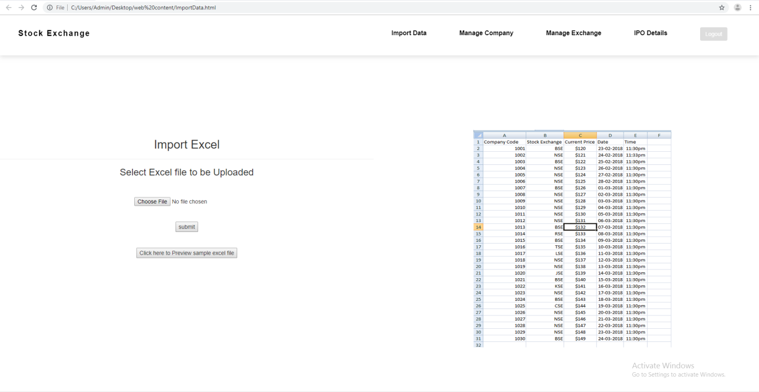

Fig :-1.3(Data Import)

**Manage Company :-** This feature allow the admin to add the company details and the company list. The admin can view the available company and get the data about the company. The admin can also deactivate the company so that can’t be used by the user for the charting and other uses. I have also introduced the responsive feature to this so that user can get the view from any of the device.

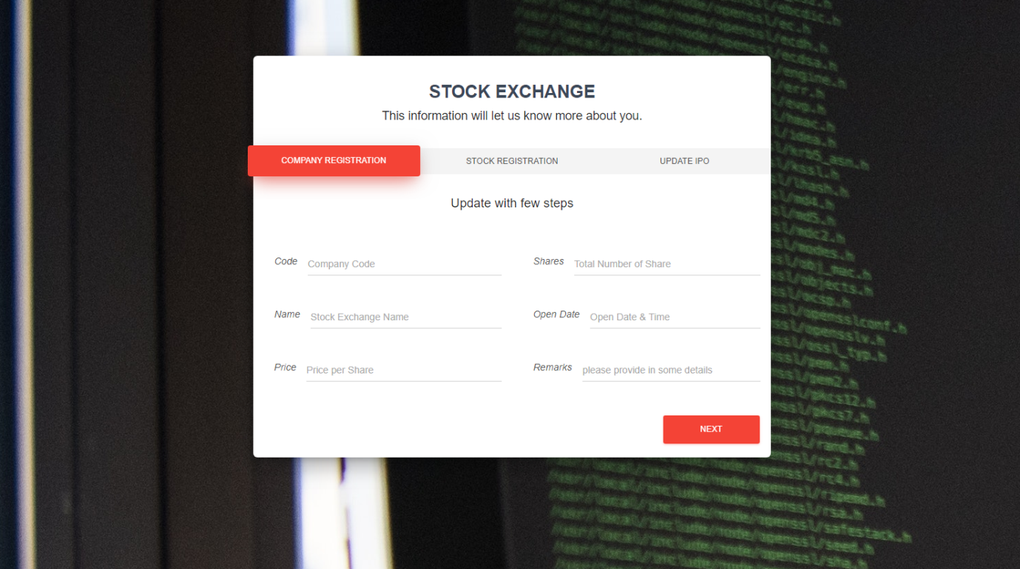

Fig: 1.4(Manage Company)

As the device size collapses the header also collapse and goes inside the logo which is the online library of fa-fa icons. Form this icon user can access an side bar which available the feature like the header.

**Manage Exchange:-** The Admin has to give the stock prices of the company that he added. So the admin first needs to register the stock of the company and get the value from the stock price. Then the admin can add the excel file to the company data to add the historical data.

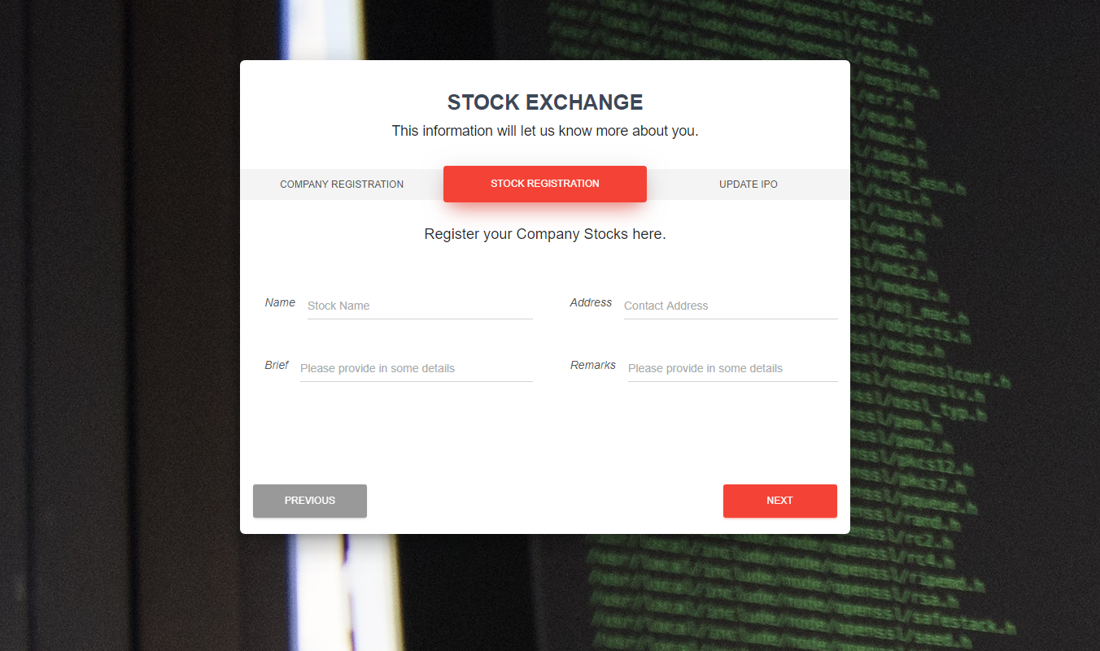

Fig :-1.7(Manage Exchange)

**IPO Planned** :- The Admin need to add the ipo details for every registered company so that user can get the investments plan of that registered company. For every user the company maintains the ipo for every shares that the user owns.

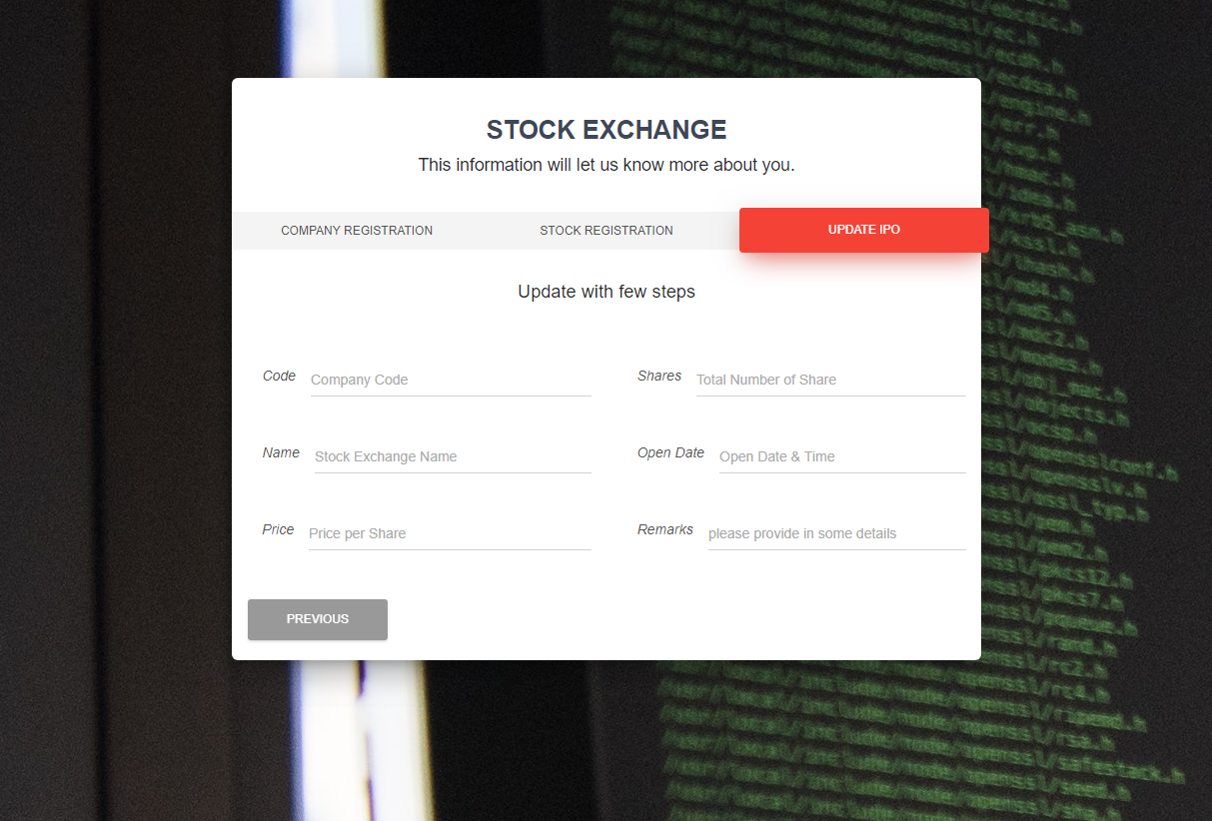

Fig :- 1.9(IPO Planned)

**User Registration &Login :-**  The user can access the stock market charting after registration and login through the portal using this portal.



Fig :-(User Login)

**User Company List:-**  The user can see the data of the company and all the companies in this tab.

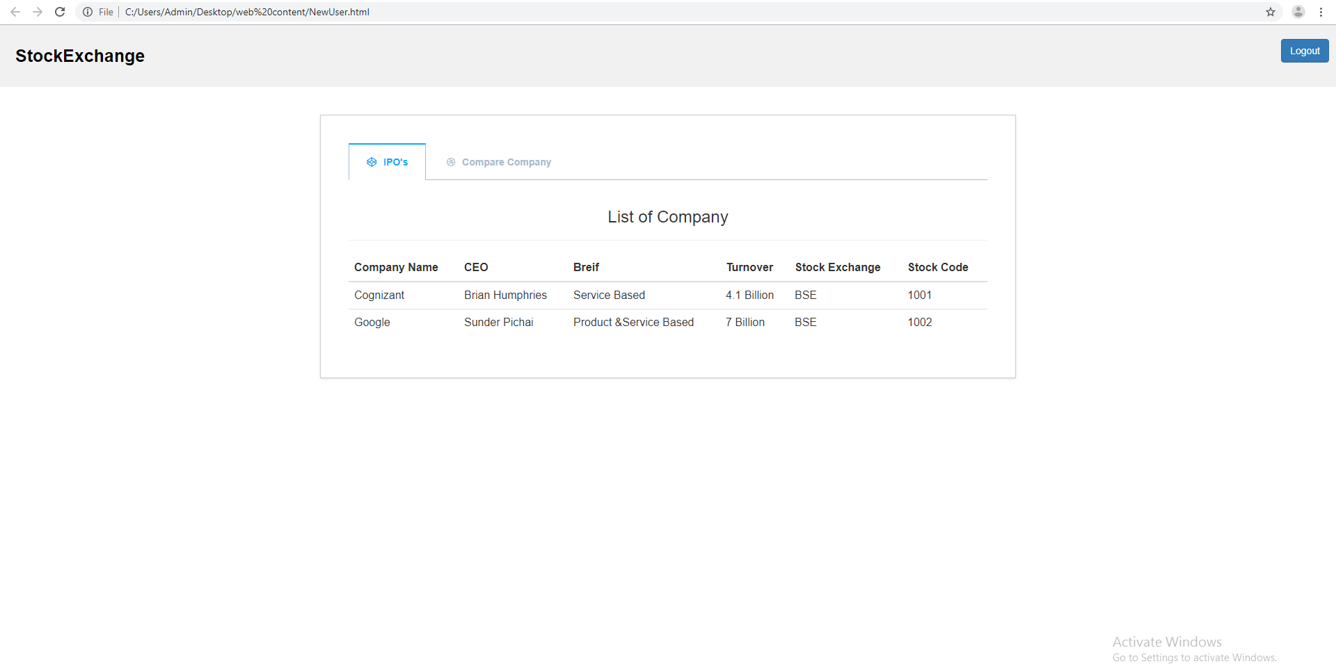

Fig :-1.13(Company List)

**User stock charting :-** In this view the user can view the charts of the company and compare between the different company charts between specific period.

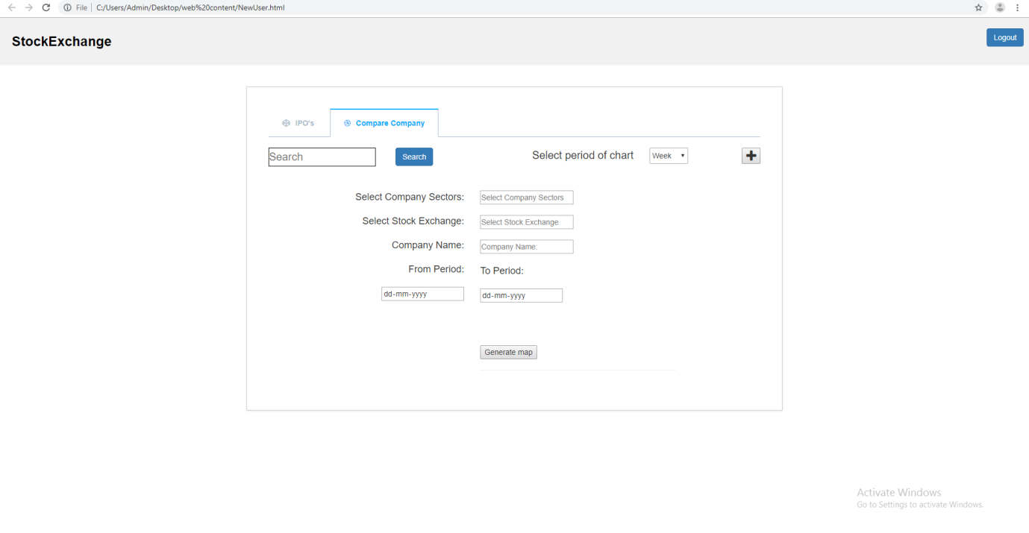

Fig :-1.14(Stock Comparison)

I have added the functionality to add the another company comparison using the child clone method to the content2.

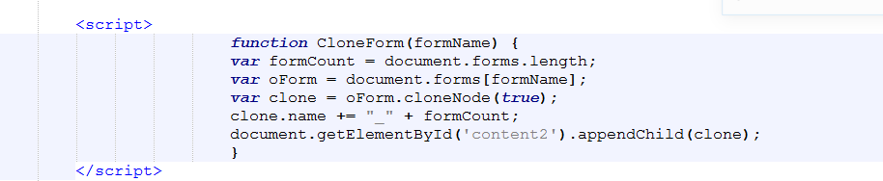

Fig:1.15(Clone script)

As the user click the fa-plus icon the user will be prompted with the new company details field.

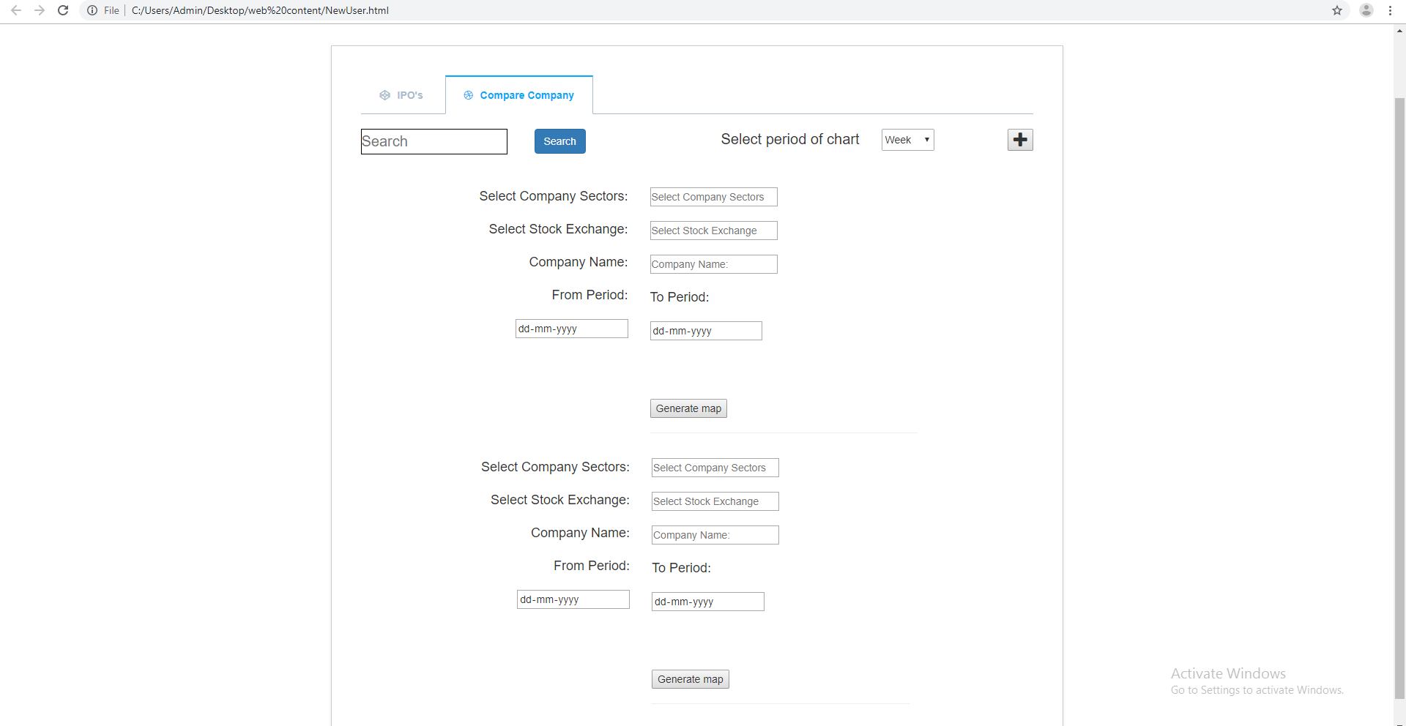

Fig :-1.16(stock charting multiple companies)

**Database schema:-** The stock market charting has the different entity classes which establish the different kinds of the relationship among them. The different entity classes are as follows.

1. Company.
2. Stock Price Details.
3. IPO’s Planned
4. Sector.
5. User.
6. Stock Exchange.

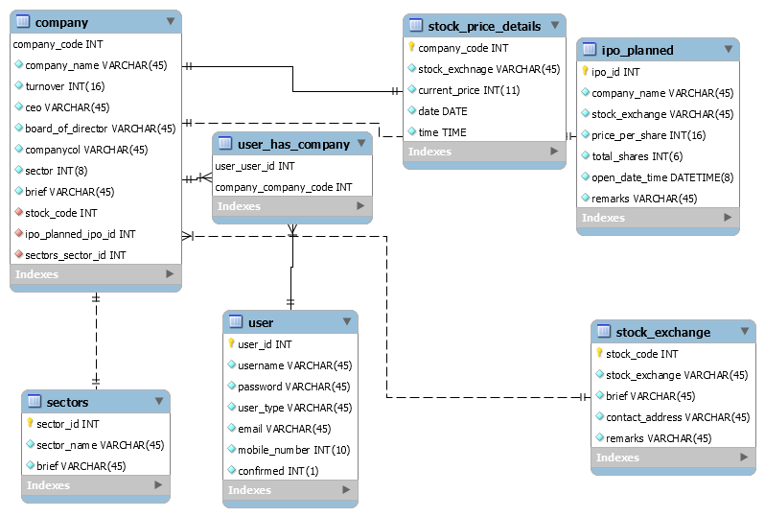

Fig :-1.17(Schema database)

REFERENCES

<https://github.com/chayangandhi/StockExchange>